OBSTACLE AVOIDANCE ROBOT
BY
MECHATRONICS ENGINEERING

COLLEGE OF ENGINEERING

BELLS UNIVERSITY OF TECHNOLOGY NEW HORIZONS

GROUP 5

SUBMITTED BY:
ADENIYI ADETOLA IDAYAT 2024/13076
UNACHUKWU UCHE JONAS 2024/13083
AWOSANYA AKOLADE OLUWATIMILEYIN 2024/13090
OSEMWENGIE ESEOSA FAVOUR 2024/13094
FABUSIWA BOLUWATIFE JEREMIAH 2024/13100

COURSE: BUT-ICT 215 (ROBOTICS 1)

SUBMITTED TO: AYUBA MUHAMMED

SUBMISSION DATE: FRIDAY, 30TH JANUARY 2026

ABSTRACT
This project is concerned with the design and construction of an Obstacle Avoidance Robot. The obstacle avoidance robot is a mobile robot designed to move independently while sensing and avoiding objects in its path without human intervention. A micro controller (AT mega 328P) was used to achieve the desired operation. An Ultrasonic sensor was used to detect any obstacle ahead of it and sent a command to the micro controller. Depending on the input signal received, the microcontroller redirected the robot to move in an alternate direction by actuating the motors which was interfaced to it through a motor driver.

TABLE OF CONTENTS
ABSTRACT i
TABLE OF CONTENTS ii
LIST OF FIGURES iv
CHAPTER ONE 1
1.3 Objectives of the Study 1
1.4 Research Questions 2
1.5 Significance of the Study 2
1.6 Scope and Limitations 2
1.7 Organization of the Study 2
CHAPTER TWO 4
LITERATURE REVIEW 4
2.1 Introduction 4
2.2 Review of Existing Similar Robots 4
2.3 Analogue Circuit Techniques in Robotics 5
2.4 Microcontroller Selection and Justification 5
2.5 Use of Proteus/Tinkercad in Industry/Education 6
2.6 PCB Design Trend in Robotics 6
2.7 Research Gap Identification 6
CHAPTER THREE 8
METHODOLOGY 8
3.1 System Block Diagram 8
3.2 Hardware Design 8
3.2.4 Simulation Results in Proteus 13
3.3 PCB Design 16
3.4 Software Development 17
3.5 Prototype Development 22
3.6 Testing and Validation Procedure 22
3.7 Ethics 23
CHAPTER FOUR 24
RESULTS AND DISCUSSION 24
4.1 Simulation Results 24
4.2 Hardware Results 26
4.3 PCB Performance Comparison 27
4.4 Discussion 27
4.5 Problems Encountered and Solution 28
CHAPTER FIVE 29
CONCLUSION AND RECOMMENDATION 29
5.1 Summary of Findings 29
5.2 Conclusion 29
5.3 Recommendations 29
5.4 Contribution to knowledge 29
5.5 Limitations 30
5.6 Suggestion or Future Work 30
REFERENCES 31
APPENDICES 32
Appendix A: Full source Code 32
Appendix B: GitHub Repository 34
Appendix C: Component Datasheets 34

LIST OF FIGURES
Figure 1: Block Diagram of the Obstacle Avoidance Robot 8
Figure 2: Analog Circuit Design of the Obstacle Avoider Project 9
Figure 3: Arduino Uno 9
Figure 4: L293D Motor Driver 10
Figure 5: Ultrasonic Sensor 10
Figure 6: Simulation Screenshot when the object was placed 18cm away 13
Figure 7: Simulation screenshot when object was placed 21cm away 14
Figure 8: Simulation screenshot when object was placed 23cm away 14
Figure 9: Circuit Diagram in Tinkercad 15
Figure 10: Diagram of the Tinkercad Simulation 15
Figure 11: Schematic Diagram of the PCB 16
Figure 12: Diagram of the 2D PCB Design 16
Figure 13: 3D Diagram of the PCB 17
Figure 14: Screenshots of Arduino Code 21
Figure 15: Flow Chart Diagram of the System 22
Figure 16: Simulation Screenshot in Proteus 24
Figure 17: Screenshot of the Simulation Log in Proteus 25
Figure 18: Screenshot of Simulation in Tinkercad 25
Figure 19: Serial Monitor results when the object was placed at a distance greater than the threshold 26
Figure 20: Serial Monitor result when object was placed at a distance less than the threshold 26
Figure 21: GitHub Repository Contributions via https://github.com/Adetolaadeniyi/Obstacle-avoidance-robot.git 34

CHAPTER ONE
INTRODUCTION
1.1 Background of the Study
In the current world robotics is a fast growing and fascinating industry. Robotics has a major role of technology and is applicable in several areas such as healthcare, business, manufacturing, education, security and transportation. Robots are progressively used to perform tasks that are repetitive, hazardous, or difficult for humans to perform. Obstacle avoidance and detection can be considered a central issue in producing mobile robots.
An obstacle avoidance robot is a mobile robot designed to move independently while sensing and avoiding objects in its path without human intervention. The design allows robots to navigate and avoid obstacles and collisions in an unfamiliar area; this is an ability that every robot in today’s world should possess. This is achieved using sensors, control circuits, actuators, and a microcontroller programmed to make real-time decisions. Obstacle avoidance serves as a foundation for more advanced systems such as autonomous vehicles, services robots, and automated surveillance systems. This project focuses on the design, simulation and implementation of an obstacle avoidance robot by integrating sensors and microcontroller programming using Proteus and Arduino.

1.2 Problem Statement
Navigation in an unknown location is a major issue for mobile robots. Mobile robots can recognize objects in its surrounding whenever it moves in a real environment but the need for an obstacle detection and avoidance is important. For example, a robot may hit obstacles which may lead to system failure, unsafe operations and destruction, this is all due to the lack of proper control mechanisms and sensing. Many older systems rely on human control, which reduces its capability and limits application in real world situations. There is a need for a more affordable and reliable robotic system that can autonomously sense obstacles and avoid running into them.

1.3 Objectives of the Study
This study aims to design, build, simulate, and implement a fully functional obstacle avoidance robotic system using analogue circuits, sensors, actuators, and microcontroller programming
The project is expected to fulfil the following objectives:
- To design and simulate a complete obstacle avoidance system using Proteus and Tinkercad.
- To integrate ultra sonic sensors for immediate decision and navigation.
- To write and refine microcontroller code for immediate control using Arduino.
- To design a professional PCB layout of the robotics system.
- To build a robot that will operate efficiently in an unknown environment
- To document the entire project and publish on GitHub

1.4 Research Questions
This study is going to answer some questions which are:
- How can the system use sensors to detect obstacles?
- What type of sensors help control the direction of a moving robot when an obstacle occurs?
- How a microcontroller can be programmed to make immediate navigation decisions?
- How efficient are simulation software like Proteus and Tinkercad in robot design and testing?
- How effective is the robotic system in navigation in an unknown area?

1.5 Significance of the Study
This study is critical because it’s the background of every autonomous robot in existence. Robotic systems can’t be efficient without this feature. The obstacle avoidance robot in this study can be used as a basic model for more advanced autonomous systems. With this study, the accident prevention of self-driving cars and other autonomous robots can be understood better allowing the relationship between humans and humanoid robots to be made better with this technology. The study also serves as a learning platform for students to understand the use of sensors, microcontroller, and autonomous control systems.

1.6 Scope and Limitations
The scope of this research includes the design, simulation, implementation, and testing of a basic obstacle avoidance robot that can detect and avoid objects. The system focuses primarily on short-range obstacle detection using commonly available sensors. It doesn’t use advanced features like artificial intelligence, mapping or machine learning.
The limitations of the study include:
- sensor have limited range
- The processing power of the microcontroller is limited
- The robot has difficulty dealing with dynamic objects
- The system has limited sensing abilities and cannot detect very thin objects
- There can be possible inaccuracies caused by environmental factors such as lighting or surface reflectivity.

1.7 Organization of the Study
This project report is divided into five chapters namely:
- Chapter One: it covers the background, problem statement, objectives, research questions, significance, scope, and limitations of the project.
- Chapter Two: it discusses the review of related literature and existing obstacle avoidance robotic systems.
- Chapter Three: it explains the methodology of the system which contains the system design, the software development, simulations, and PCB design.
- Chapter Four: it discusses the results obtained from simulations and testing of the system.
- Chapter Five: it provides the conclusion, recommendations, and suggestions for future work.

CHAPTER TWO

LITERATURE REVIEW

2.1 Introduction
Obstacle detection and avoidance is a major part of autonomous robots, as it is a fundamental requirement for safe navigation by the robots in unknown areas. Below is a review of various existing systems that has proposed technologies for implementing obstacle avoidance.

2.2 Review of Existing Similar Robots
Marvin (Mobile Autonomous Robotic Vehicle for Indoor Navigation) developed by the Mechatronics group in the Department of physics and electronic Engineering is a mobile robot which was built for indoor navigation. It integrated laser sensors such as ultrasonic sensors to measure distance to obstacles, infrared (IR) sensors for short-range obstacle detection, and Wheel encoders to estimate position and movement. [Christopher, 2004]
RAVON (Robust Autonomous Vehicle for Off-road Navigation) developed by the Robotics Research Lab at the University of Kaiserslautern in Germany, is a ground vehicle built for avoiding collisions in outdoor terrain. [RAVON, 2021] It uses 3D laser sensors for mapping the environment and detecting obstacles, stereo camera systems for visual perception and obstacle detection over mid-range distances, and inertial Measurement Unit (IMU), magnetic field sensor and GPS receivers for localization and positioning.
In the early 1991 at the LAMI laboratory Khepera was first developed. It is a mobile robot designed primarily for research purposes on autonomous navigation and avoiding obstacles. It detects obstacles using the infrared sensors placed around its body and based on the sensor readings, it adjusts motor speed and directions to avoid collisions. It also integrates differential wheeled locomotion, and microcontroller computing. [Mondada, 1999]
Allen was introduced in the late 1980’s by Rodney A. Brooks and his team at the MIT AI Laboratory. This is one of the early obstacle avoidance robots that incorporated a reflexive layer using sonar and layered control. Allen implemented three layered behaviours Avoidance, Wander, and Explore which allowed it to enable robust reactive navigation. [Brooks, 1990]
CajunBot by team CajunBot from the University of Louisiana at Lafayette was built for DARPA Grand Challenge back in 2004. CajunBot uses GPS positioning, LIDAR, radar, and sonar sensors to spot and dodge obstacles. It is a fully working system that leans on AI for obstacle avoidance in rough areas. [CajunBot, 2004]
Roomba iRobot is a smart home vacuum that uses an obstacle avoidance system to avoid furniture while vacuuming. It uses IR sensors, bump sensors, and cliff sensors to detect obstacles, contact with furniture or walls, and prevent it from falling down the stairs or ledges. it also has an embedded microcontroller for real time control. [iRobot, 2002]
Parrot Anafi Drone was developed by Parrot SA, a drone and robotics company based in France in 2018. This is robot drone used to map the land from the air. It autonomously navigates through the air, avoiding trees, buildings, and any obstacles with its built-in sensors. [Ridden, 2018]
A team of engineers from School of Mechatronic Engineering, China University of Mining and Technology proposed a multi sensor intelligent robot for obstacle avoidance based on road sign detection. Three ultrasonic sensors were used to enhance detection, compatibility, and reliability. The study showed that the use of multiple sensors improve environmental awareness, reduces blind spot and allows smoother decision making in unknown environments. [ Jianwei et al., 2021]

2.3 Analogue Circuit Techniques in Robotics
Analog Circuits are key in robotics because of their ability to process continuous signals, manage power efficiently and carry out real-time control at the hardware level. They include:
1. Signal Conditioning and Sensing: Analogue circuits preprocess sensor outputs before digital acquisition
2. Motor and Actuator Control
3. Hybrid Analogue-Digital Control
4. Fluidic Analogue Control
5. Machine Learning-Assisted Analogue Design

2.4 Microcontroller Selection and Justification
Selecting the microcontroller is an important factor designing an obstacle-avoiding robot because it serves as the brain of the operation, by reading sensor data and controlling the motors. In this project the Arduino Uno was chosen because it is budget friendly, efficient, easy to programme, and very compatible with the sensors
The key consideration for the selection includes:
- Processing Power: The microcontroller needs to be able to handle signals from any sensor used and quickly send commands to the motors. The Arduino Uno uses a chip, which runs at 16 MHz and that is fast enough for basic real-time obstacle detection and motor control.
- Memory and Storage: there is a need for a microcontroller that has enough memory to store the robot’s program. The Uno packs 32 KB of Flash and 2 KB of SRAM which is enough for our robot programmes.
- Programming and Community Support: Arduino’s programming environment is beginner friendly. There are a lot of libraries, guides, and troubleshooting tips making it way easier and faster to get work done.
- Power Consumption: for this project we need a microcontroller that can support the use of our battery system. The board consumes little power making it perfect for our battery powered system.
- Cost and Availability: Arduino Uno’s are cheap and easy to find making it suitable for prototyping and educational projects
The Arduino Uno meets the above requirement. It handles real-time processing, manages motor control, and allows addition of new features in the future. It works smoothly with the ultrasonic sensor and motor drivers.

2.5 Use of Proteus/Tinkercad in Industry/Education
Proteus and Tinkercad are electronic design tools used for designing, debugging and simulating electronic circuits circuit simulations. Proteus is a professional industry standard software mainly used by electronic design engineers, R&D professionals and technicians while Tinkercad is a beginner friendly web-based software used by DIYers, beginners, K-12 students and educators to create schematics and electronic prints for manufacturing printed circuit boards. Proteus and Tinkercad is also an essential aid in teaching and learning electronics and embedded systems for students. It allows a safe and cheap method where students can experiment with circuit design and microcontroller programming without the need for expensive hardware.

2.6 PCB Design Trend in Robotics
A Printed Circuit Board (PCB) is a mechanical base used to hold and connect the components of an electric circuit. PCB design is the entire process of creating a layout for Printed Circuit Board which involves planning how electrical components are placed and their interconnections. PCB Design trends include:
- High-Density Interconnect (HDI) PCBs: it is boards that allows more components into smaller spaces than traditional PCBs.
- Flexible and Wearable PCBs: it is a thinner, easily cut into complex shape, and can fit the shape of the device they are placed inside
- Embedded Sensors and IoT Integration: PCBs now embedding sensors directly, therefore reducing messy wiring and improving real-time reactivity.
- Thermal and Power Management: this PCB design focuses on reducing heat produced and stable power delivery. This arises with robots handling higher loads.
- Sustainability and Reliability: PCB materials are becoming eco-friendly to ensure they last longer in industrial environments and reduce damages to the ecosystem system.

2.7 Research Gap Identification
In the design of obstacle avoidance robots, we still face many challenges in:
- How the robots react to a dynamic environment.
- Research is still needed to improve sensor combination and coordination.
- Optimizing the robots to be energy efficient and creating algorithms for low-power hardware.
- There is a need to improve human-robot interaction balancing safety with efficiency.
Dealing with these gaps will make robots more dependable to operate better in real-world applications. Future research will also help with mixing classical path-planning approaches with AI-based learning.

CHAPTER THREE

METHODOLOGY

3.1 System Block Diagram

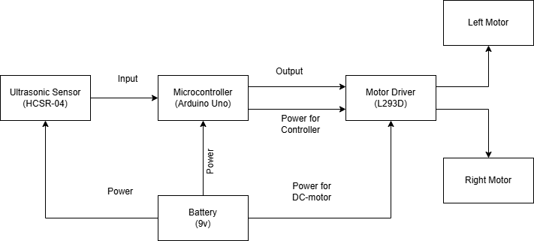
Figure 1: Block Diagram of the Obstacle Avoidance Robot

3.2 Hardware Design
The hardware design of the obstacle-avoidance robot has the microcontroller at the centre of the system. The system uses several components to enable autonomous movement and obstacle detection.
  - Microcontroller: The microcontroller is processes sensor data, make decisions, and control the motors.
  - Sensors: The robot uses an ultrasonic sensor to detect obstacles in its path. These sensors measure the distance of objects and send signals to the microcontroller for decision-making.
  - Motor Drivers and DC-motor: A motor driver connects the Arduino with the DC motors, allowing control of motor direction and speed.
  - Power Supply: The system is powered by a 9V battery, which supplies power to the Arduino and motor driver. Proper voltage regulation ensures that all components operate safely and efficiently.
  - PCB Design: All components are mounted on a printed circuit board (PCB) to improve stability and reduce electrical noise.
The combination of these components forms a hardware platform capable of detecting obstacles and navigating autonomously. The design prioritizes reliability, efficient power distribution, and modularity for potential upgrades.

3.2.1 Analog Circuit Design
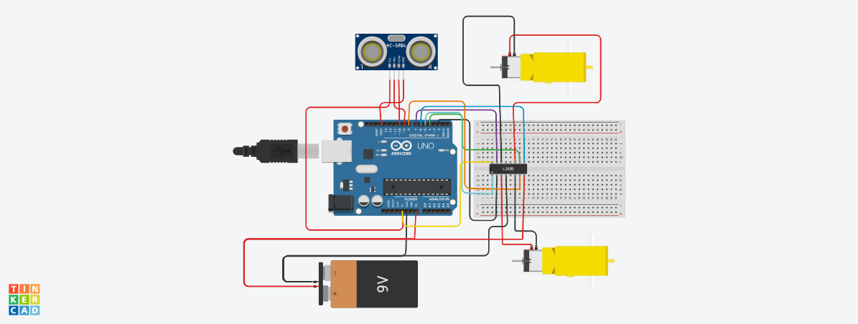

Figure 2: Analog Circuit Design of the Obstacle Avoider Project
The analogue circuit design includes:
- Arduino Uno: The Arduino Uno is an open-source board built using ATmega328 microcontroller. The microcontroller is the brain of the robot that collects the information from various input devices and then it executes a program and in accordance with it controls the output devices. The board contains a set of digital and analogue pins that are I/O pins that connect the board to other components. The board is used electronic projects and used to design the circuit.

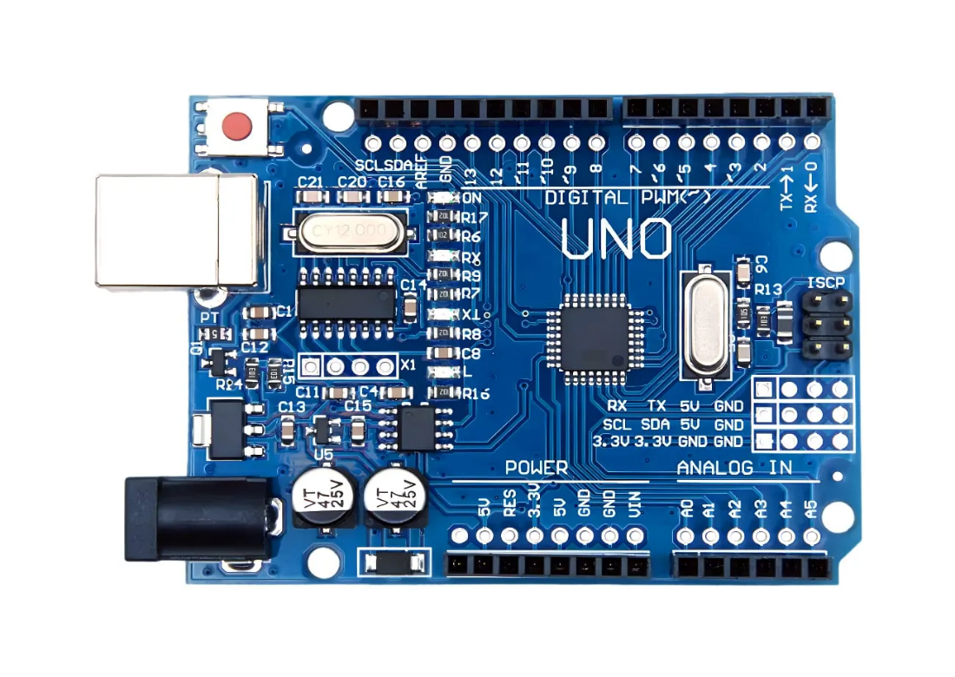
Figure 3: Arduino Uno

- L293D Motor driver: A motor driver is a circuit that controls movement and speed of electric motors. They provide accurate movement and operation by converting low-power control impulses into the high-power outputs needed by motors.

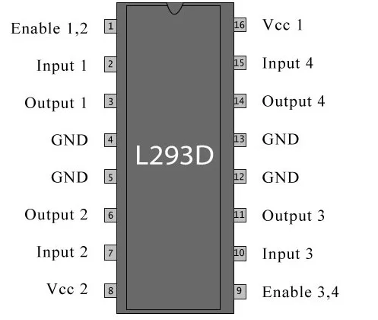
Figure 4: L293D Motor Driver

- Ultrasonic sensor: Ultrasonic sensors allow us to equip our robot with a means of perceiving surrounding objects, an alternative to technical vision. The sensor uses ultrasonic waves to measure distance by evaluating the target by examining echoes from radio or sound waves.

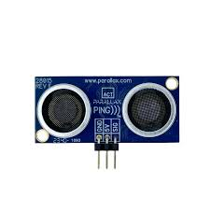
Figure 5: Ultrasonic Sensor

- Battery: Batteries and similar devices accept, store, and release electricity on demand. Batteries use chemistry, in the form of chemical potential, to store energy, just like many other everyday energy sources.

3.2.2 Microcontroller Selection and Pin Mapping
There are many ways to build an Obstacle avoider robot in our project we used one Ultrasonic Sensor (front) and two IR sensor (Left/Right) so that our robot has eyes in all three directions. This makes it much smarter and faster by detecting objects in all three sides and manoeuvre accordingly. Here we are using the Arduino Uno which contains the ATmega328P for this obstacle avoiding robot.
The Arduino Uno was selected as the core microcontroller because of its versatility and affordability for an obstacle avoidant robot. it is widely available and fully compatible with both Proteus and Tinkercad simulation environments required for this project. The complete circuit diagram of the Arduino based obstacle avoiding robot is shown in fig 3. As seen above we have used an Ultrasonic sensor to measure the distance of the object that is present ahead of the robot. We have also used a L293D motor driver module to drive the two motors present in this project. These are just ordinary DC gear motors for wheels and hence can be derived very easily

Pins Mapping Table

Component | Pin name | Arduino
Ultrasonic Sensor (HC-SR04) | Vcc | 5v
Ultrasonic Sensor (HC-SR04) | Gnd | Gnd
Ultrasonic Sensor (HC-SR04) | Trig | D9
Ultrasonic Sensor (HC-SR04) | Echo | D10
Motor Driver (L298N) | IN1 | D2
Motor Driver (L298N) | IN2 | D3
Motor Driver (L298N) | ENA | D5
Motor Driver (L298N) | IN3 | D4
Motor Driver (L298N) | IN4 | D7
Motor Driver (L298N) | ENB | D6
Arduino uno | GND | GND
Power supply | Battery+ | L298N
Power supply | Battery- | L298N

3.2.3 Proteus Schematics

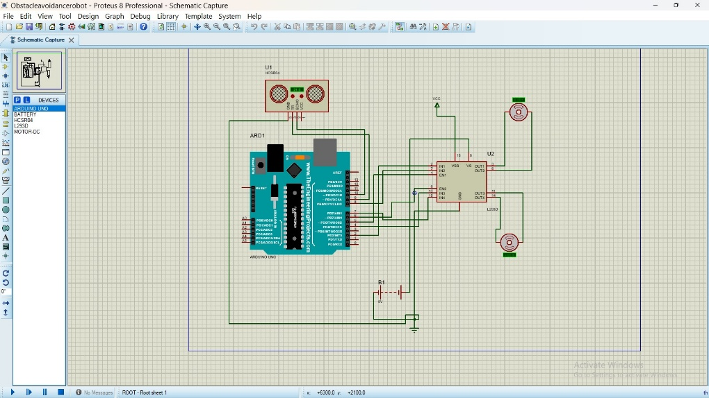
Fig. 3.6: Schematic Diagram of Proteus

The schematic diagram developed in Proteus illustrates the complete electronic design of the obstacle avoidance robot. It shows the sensors, control, motors, and power which lets the robot spot obstacles and move around them.
The Arduino Uno microcontroller serves as the brain of the entire system. The Arduino reads signals from the ultrasonic sensor and makes decision based on its programming on how to control the movement of the robot. The Arduino’s digital pins connect to the motor driver inputs while the enable pins connects to PWM pins which allows speed control of the motors.
An HC-SR04 ultrasonic sensor is used for the detection of obstacles. The trig pin of the sensor is connected to a digital output pin of the Arduino Uno to send out ultrasonic pulses, while the echo pin is connected to a digital input pin to receive the reflected signal. The sensor gets powered by the Arduino’s 5 V supply and shares a common ground with the rest of the system.
A L293D motor driver is used to connect the Arduino with the DC motors. The Arduino doesn’t supply enough current to drive the motors directly, so the motor driver takes the weak signal from the Arduino Uno and increases it. The driver helps controls the ways the motors spin and how fast they move based on the control signal received from the Arduino Uno.
Two DC motors are connected to the motor driver outputs. These motors are the parts that perform all movements in the robots.
A DC battery powers the system. The motor driver gets its own supply through the VCC2 pin, while the Arduino and the sensor both run on 5 V. All components have a shared ground which is essential for a more stable and reliable operation.
The circuit was designed and simulated using Proteus software to verify the accuracy of the connections and to test the functional behaviour of the robot before physical implementation. This simulation approach allows the system’s operation to be evaluated in a controlled environment without the need for immediate hardware assembly.

3.2.4 Simulation Results in Proteus
During the simulation, we had adjusted the ultrasonic sensor to imitate the presence of obstacles at different distances. If the obstacle was more than 20cm away (the threshold) the robot moved forward, but when the obstacle was less than or equal 20cm the robot stopped and changed its direction towards either the left or the right.

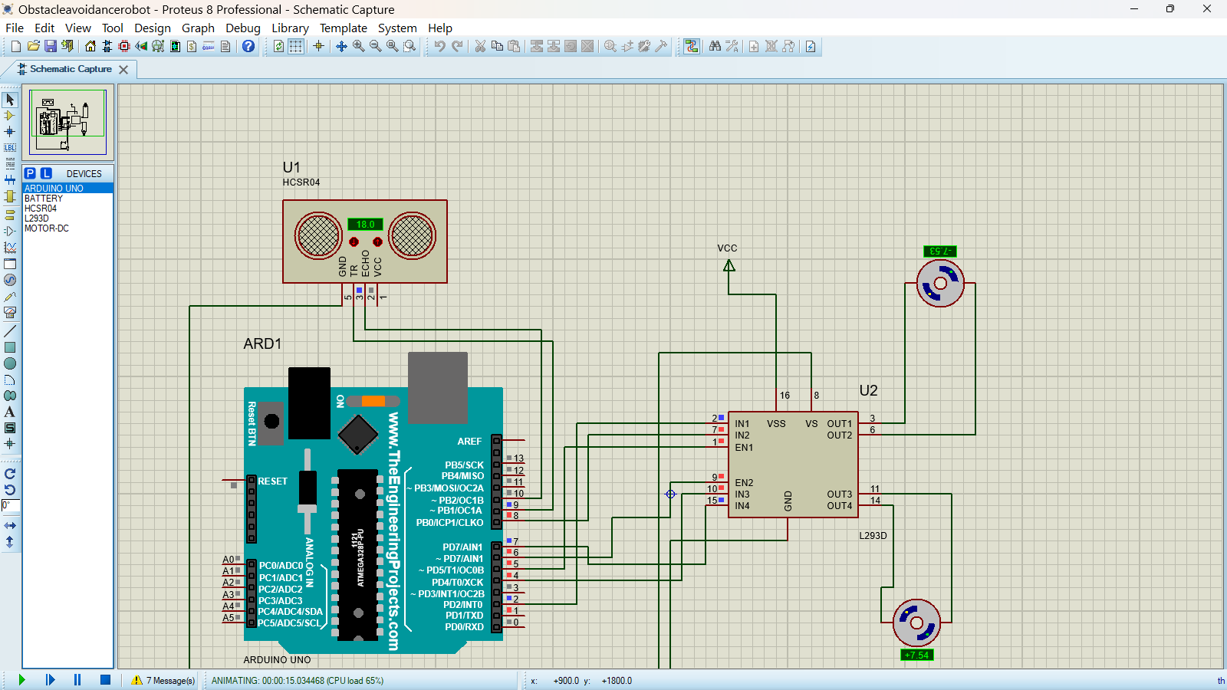
Figure 6: Simulation Screenshot when the object was placed 18cm away

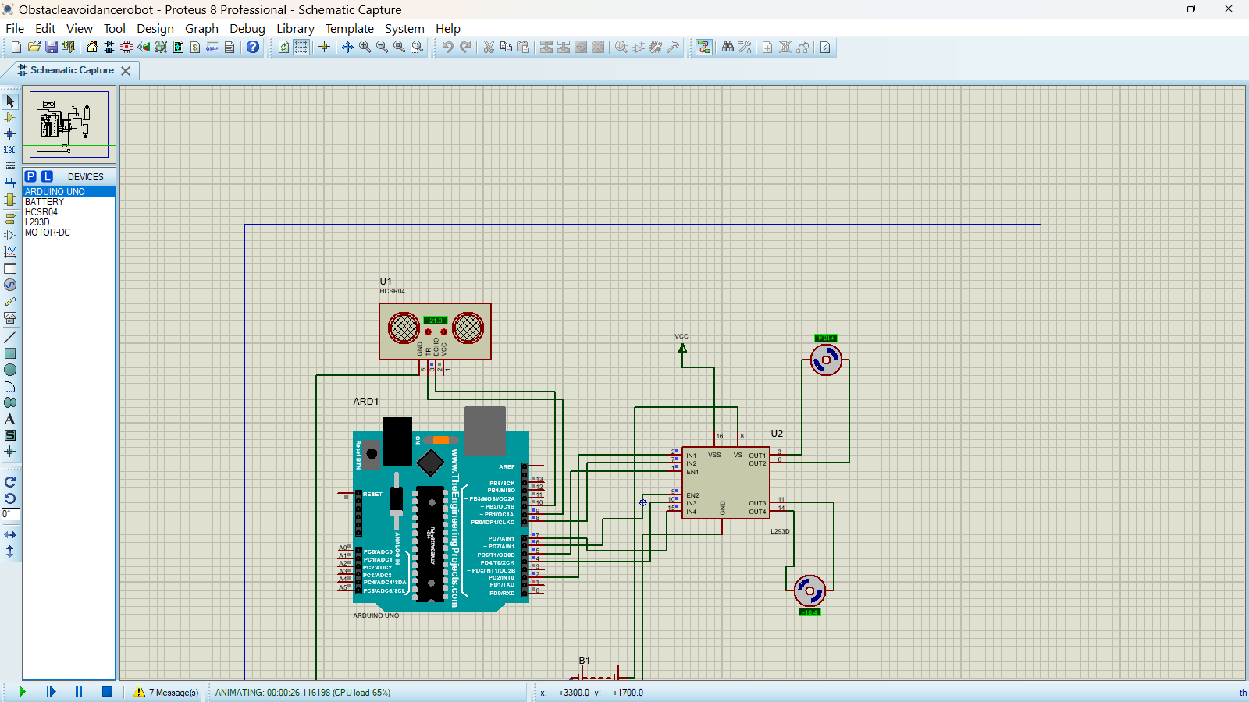
Figure 7: Simulation screenshot when object was placed 21cm away

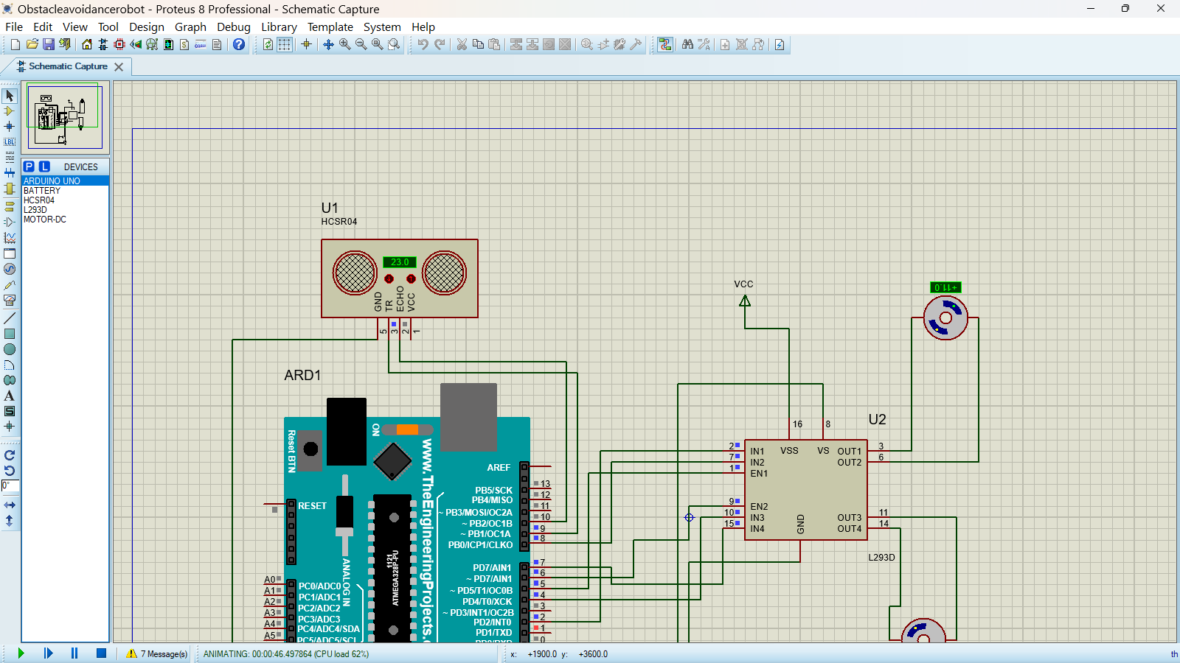
Figure 8: Simulation screenshot when object was placed 23cm away

By the time we were done with the simulation what the results confirmed was that the designed system responded correctly to any obstacle detection. Although, a warning indicating that the simulation was not running in real time due to high CPU load. it simply means that the simulation is more demanding than your computer can process at normal speed. This will result in the simulation running slightly slower than it would in real life, even though it still functions and properly correctly.

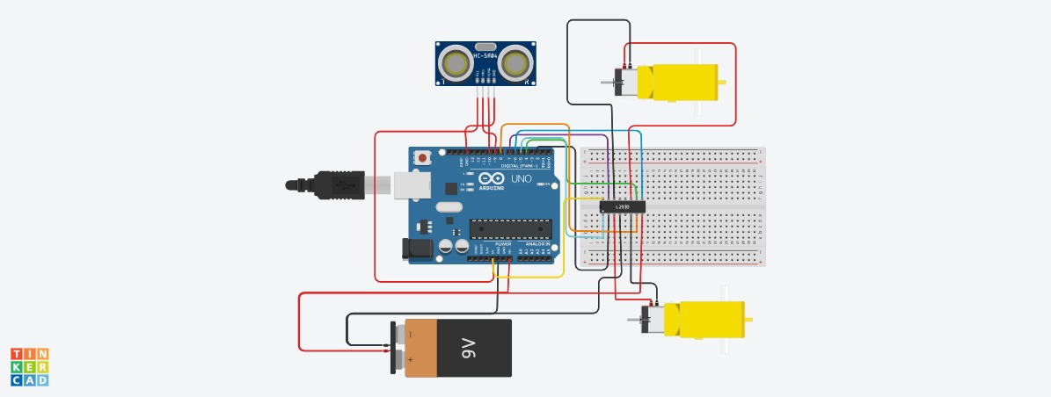
3.2.5 Tinkercad Simulation
Figure 9: Circuit Diagram in Tinkercad
The Tinkercad simulation allowed us to test and check the behaviour of our robot in a virtual environment before building the physical prototype. The simulation helped in understanding how the sensors and motors interact and ensured that the code used works correctly. All the components were placed and connected in Tinkercad according to the schematic design. The motor pins and sensor pins were configured to match the definitions used in the Arduino code. A virtual power source was connected to simulate the robot’s energy supply. The Arduino code controlling the robot’s obstacle avoidance logic was uploaded to the virtual Arduino. This virtual trial run gave us the confidence that our hardware and software were in sync.

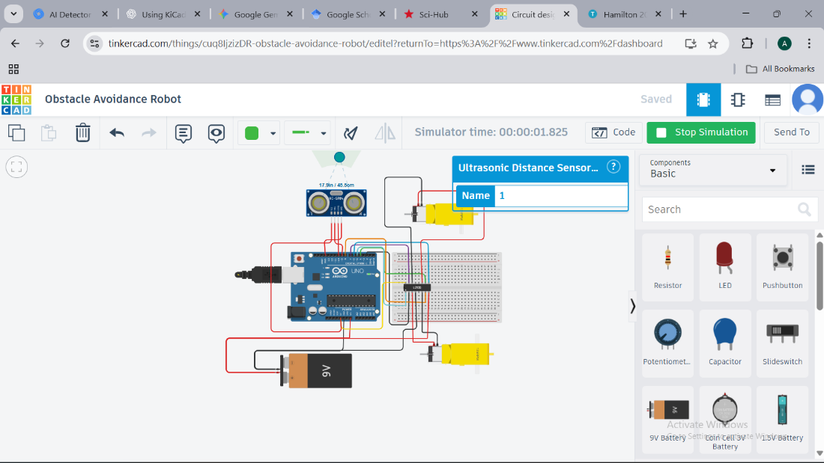
Figure 10: Diagram of the Tinkercad Simulation

3.3 PCB Design
The printed circuit board (PCB) was designed to serve as a compact and reliable platform for integrating all the electronic components of the obstacle avoidance robot. Instead of using extensive jumper wires, the PCB provides a cleaner and more organized hardware structure, which improves mechanical stability, reduces wiring errors, and enhances the overall reliability of the system. We used KiCad, an open-source design tool to build the PCB of our system.
The schematic includes an Arduino Uno microcontroller, an L293D motor driver, an HC-SR04 ultrasonic sensor interface, DC motor connections, and power supply components. The components were placed in a way to optimize the signal flow and functionality of the system. The Arduino Uno was placed at the centre of the board to allow easy access to its input and output pins. The L293D motor driver was placed near to the DC-motor to keep high-current paths short, which reduces electrical noise. The ultrasonic sensor header was placed at the front edge of the PCB for easy mounting, while the power connectors were positioned to ensure a straightforward connection to the 9V battery.
Wider copper tracks were used for motor power and supply lines to safely carry higher currents, while thinner tracks were used for control and sensor signals. We ran KiCad’s Design Rule Check (DRC). This allowed us to identify and fix minor errors, such as overlapping traces or clearance issues. Once the board cleared all checks, we generated the Gerber files for manufacturing. Overall, the PCB design brings combines all the parts together into a sturdy, tidy, and reliable hardware platform for the robot.
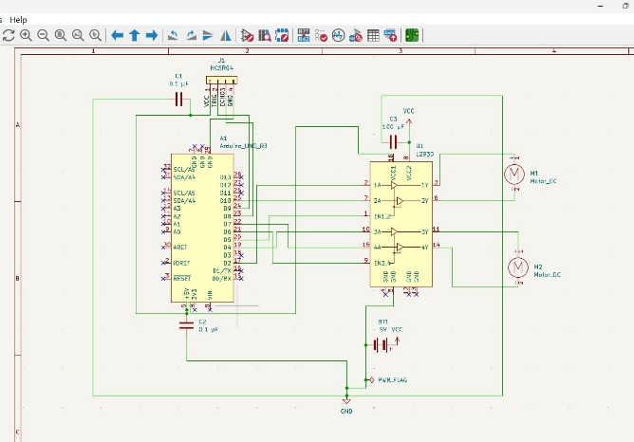
Figure 11: Schematic Diagram of the PCB
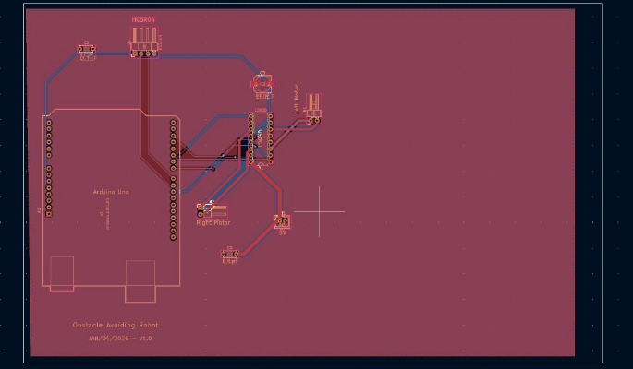
Figure 12: Diagram of the 2D PCB Design

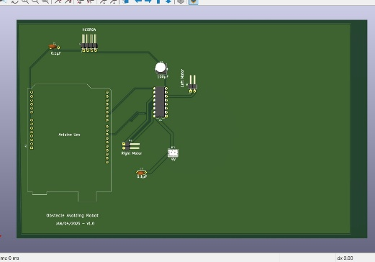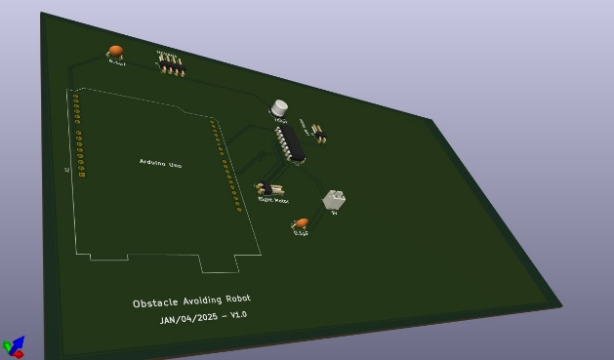
Figure 13: 3D Diagram of the PCB

3.4 Software Development

3.4.1 Arduino Code
The Arduino code used in this project is divided into six parts. Each part performs its own specific function.
- Pin Definitions: At the beginning of the program, the microcontroller pins were assigned to motors and ultrasonic sensor pins. The threshold distance to detect obstacles was defined.
Code:
#define ENA 5 // PWM pin for left motor speed
#define IN1 2 // Left motor direction pin 1
#define IN2 8 // Left motor direction pin 2

#define ENB 6 // PWM pin for right motor speed
#define IN3 4 // Right motor direction pin 1
#define IN4 7 // Right motor direction pin 2

#define TRIG_PIN 9 // Ultrasonic trigger pin
#define ECHO_PIN 10 // Ultrasonic echo pin
#define THRESHOLD 20 // Obstacle distance threshold in cm

- Global Variables
Code:
Bool turnSide = true; // true = turn right, false = turn left
Long distance = 0;
turnSide keeps track of which direction to turn when an obstacle is detected. While the distance stores the measured distance from the ultrasonic sensor.
- Setup Function: The setup function initializes all pins and starts serial communication for debugging / monitoring distance.

Void setup() {
// Motor control pins as outputs
pinMode(ENA, OUTPUT);
pinMode(IN1, OUTPUT);
pinMode(IN2, OUTPUT);
pinMode(ENB, OUTPUT);
pinMode(IN3, OUTPUT);
pinMode(IN4, OUTPUT);

// Ultrasonic pins
pinMode(TRIG_PIN, OUTPUT);
pinMode(ECHO_PIN, INPUT);

Serial.begin(9600); // start serial communications at 9600 bps
}

- Motor Functions: The motor function controls the robot’s movement and the speed of the motor
Code:
Void moveForward() {
digitalWrite(IN1, HIGH);
digitalWrite(IN2, LOW);
digitalWrite(IN3, HIGH);
digitalWrite(IN4, LOW);

analogWrite(ENA, 150);
analogWrite(ENB, 150);
}

Void turnLeft() {
digitalWrite(IN1, LOW);
digitalWrite(IN2, HIGH);
digitalWrite(IN3, HIGH);
digitalWrite(IN4, LOW);

analogWrite(ENA, 150);
analogWrite(ENB, 150);
}

Void turnRight() {
digitalWrite(IN1, HIGH);
digitalWrite(IN2, LOW);
digitalWrite(IN3, LOW);
digitalWrite(IN4, HIGH);

analogWrite(ENA, 150);
analogWrite(ENB, 150);
}

Void stopRobot() {
digitalWrite(IN1, LOW);
digitalWrite(IN2, LOW);
digitalWrite(IN3, LOW);
digitalWrite(IN4, LOW);

analogWrite(ENA, 0);
analogWrite(ENB, 0);
}
- Ultrasonic Function: The ultrasonic function measures distance using ultrasonic sensor and returns the distance in centimetres.
Code:
Long readDistance() {
// Send trigger pulse
digitalWrite(TRIG_PIN, LOW);
delayMicroseconds(2);
digitalWrite(TRIG_PIN, HIGH);
delayMicroseconds(10);
digitalWrite(TRIG_PIN, LOW);

// Read echo pulse duration
Long duration = pulseIn(ECHO_PIN, HIGH);

// Convert to distance in cm
Long cm = duration * 0.034 / 2;
Return cm;
}

- Main Loop: The main loop continuously measures distance and stops and turns when an obstacle is closer than the threshold.it also alternates turn direction using turnSide and moves forward if no obstacle detected.
Code:
Void loop() {
Distance = readDistance();
Serial.print(“Distance: “);
Serial.print(distance);
Serial.println(“ cm”);

If(distance < THRESHOLD) {
stopRobot(); // stop before turning

if(turnSide){
Serial.println(“Turning Right”);
turnRight();
} else {
Serial.println(“Turning Left”);
turnLeft();
}

Delay(500); // Adjust turn duration
stopRobot();
delay(100); // Short pause

turnSide = !turnSide; // Flip direction for next obstacle
} else {
moveForward();
}
}
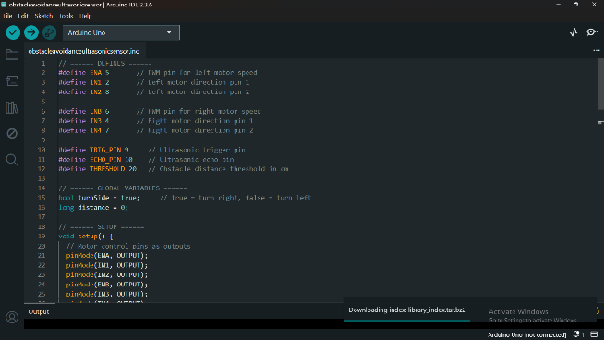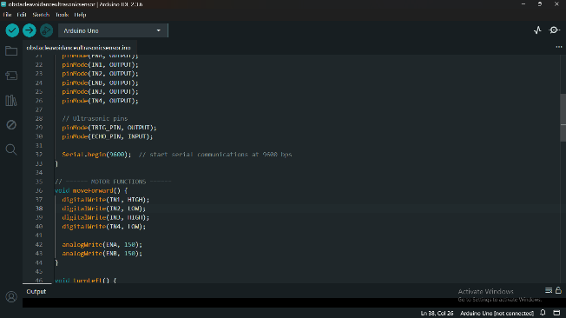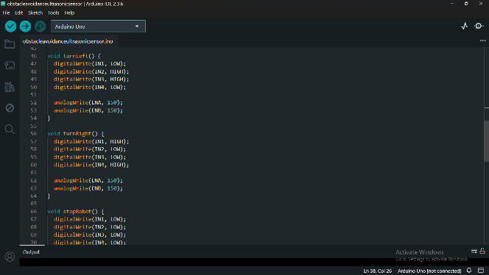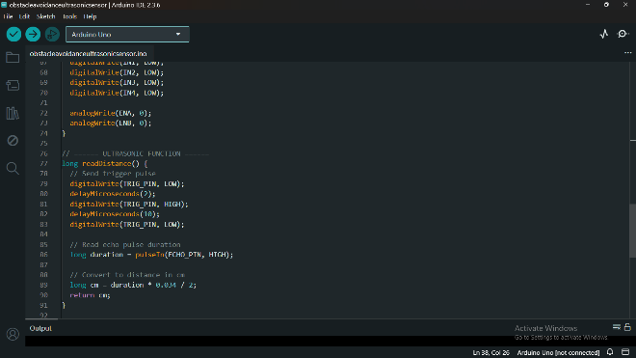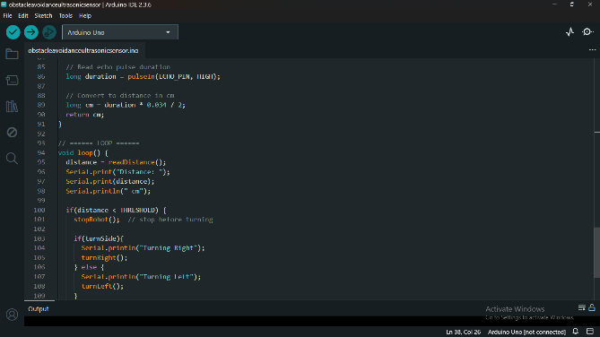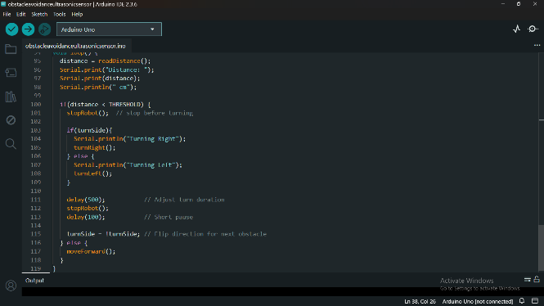
Figure 14: Screenshots of Arduino Code

3.4.2 System Algorithm
The robot’s behaviour is run by a continuous "Sense-Think-Act" cycle. The following algorithm outlines the logic programmed into the Arduino Uno to manage obstacle avoidance.
- Initialization
- Configure Motor pins and Ultrasonic Trigger as Outputs.
- Configure Ultrasonic Echo as Input.
- Set default turning direction and movement speed.
- Sensing Cycle
- Trigger: Emit a 10μs sonic pulse.
- Calculate: Measure echo return time and convert to distance (cm).
- Decision Logic
- IF Distance 20cm:
  - Command motors to Move Forward.
- ELSE (Obstacle Detected):
  - Stop: Halt all motor activity.
  - Turn: Rotate Left or Right based on the current toggle state.
  - Toggle: Flip the turn direction for the next encounter to ensure spatial variety.
- Repeat
- Continuously loop the sensing and decision cycle to maintain real-time navigation.

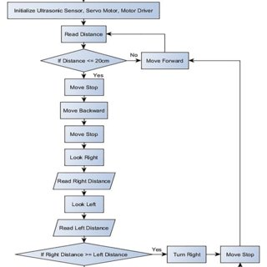
3.4.3 Flow Chart
Figure 15: Flow Chart Diagram of the System

3.5 Prototype Development
The whole development process consists of attaching the rotating parts (motor drivers), attaching the Arduino Uno board, attaching the motor driver, attaching the Ultrasonic sensor, programming codes for motion procedure, motor rotation procedure, and codes for the whole robot operation procedure and adding the battery component. All the parts were assembled on a PCB based on the schematic design. The system was then tested by placing obstacles at different places. This revealed that our robot was functioning properly.

3.6 Testing and Validation Procedure
We carried out testing and validation stage to evaluate the performance of our obstacle avoidance robot to ensure it meets all the functional requirements. The system was tested using Proteus software, and Tinkercad. The physical prototype was also tested
In proteus we tested the overall circuit, including the Arduino Uno, ultrasonic sensor, DC-motor, L2938D, and battery using the proteus simulator. The simulation helped us correct errors in our code and fix wiring that were incorrectly placed. After all errors were corrected, the simulation the results showed us that our robotic system responded correctly to any obstacle detection.
In Tinkercad we tested and checked the behaviour of our robot in a virtual environment before building the physical prototype. The simulation was continued for a continued for a period to observe long ter results. After the simulation ended, it helped us understand how the sensors and motors interact
The physical prototype of our system was assembled and tested. The robot was placed on a flat surface, while we placed obstacles at different distances in front of it. When we powered it on, it moved forward and successfully detected and avoided the obstacles we placed around it. During detection, the robot stopped and changed its direction to avoid colliding with our set obstacles. We repeated the test multiple times and observed the results The results confirmed that the robot performed as it was designed and met our aim of the project

3.7 Ethics
Ethical and safety considerations were observed throughout the implementation of this project. The robot was tested in a closed and controlled environment to avoid injury or property damage. This project was carried out strictly for educational purposes, and every source used was properly credited, no component or software was used wrongly.

CHAPTER FOUR

RESULTS AND DISCUSSION

4.1 Simulation Results
The results of our simulation in Proteus confirmed was that our Obstacle Avoiding robot responded correctly to any obstacle detection. During the simulation, the ultrasonic sensor measured the distance between the robot and nearby obstacles accurately. When the distance was higher than the threshold of 20 cm, the robot moved forward continuously, indicating normal navigation in a clear path. The motors rotated at a steady speed, confirming correct motor driver operation and PWM control.
When an obstacle was placed within 20 cm of the robot, the simulation showed an immediate response. The robot stopped momentarily and executed a turn. The robot alternated between left and right turns. This behaviour demonstrated that the decision-making logic was functioning correctly and prevented the robot from repeatedly turning in the same direction.
Proteus simulation couldn’t properly represent some real-world factors such as surface friction, battery voltage drops, and sensor noise. Despite these limitations, the simulation results confirmed that the system is suitable for physical implementation.

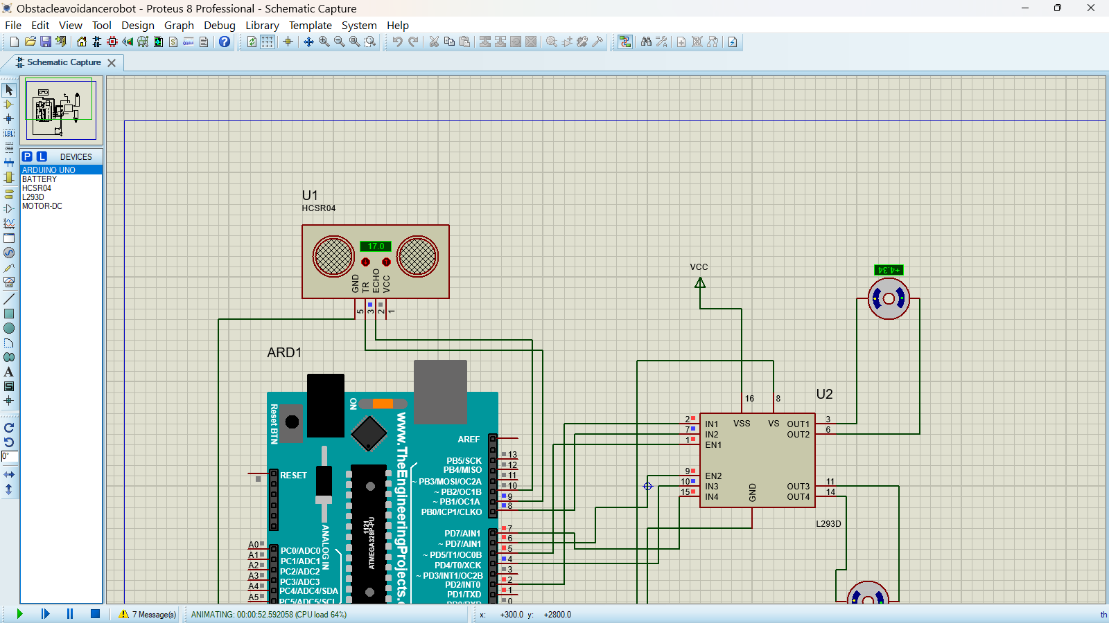

Figure 16: Simulation Screenshot in Proteus
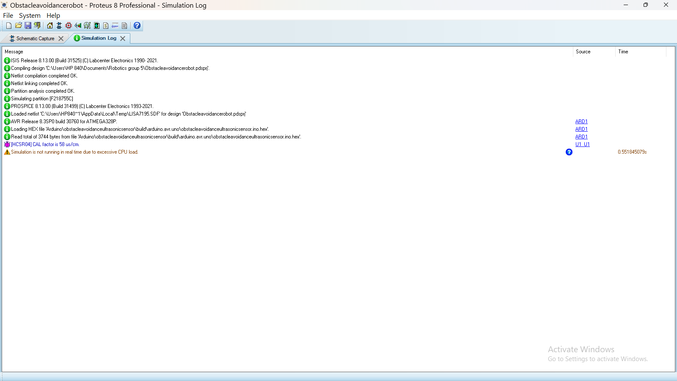
Figure 17: Screenshot of the Simulation Log in Proteus
The Tinkercad simulation results showed that all the components were placed correctly and functioned properly. During the simulation, the ultrasonic sensor measured the distance between the robot and nearby obstacles accurately. When the distance was higher than the threshold of 20 cm, the robot moved forward continuously, indicating normal navigation in a clear path. The motors rotated at a steady speed, confirming correct motor driver operation and PWM control.
When an obstacle was placed within 20 cm of the robot, the simulation showed an immediate response. The robot stopped momentarily and executed a turn. The robot alternated between left and right turns. This helped prevent the robot from repeatedly turning in one direction and getting stuck. The Serial Monitor displayed the distance readings, making it easy to confirm that the ultrasonic sensor was detecting obstacles accurately. The simulation helped in understanding how the sensors and motors interact and ensured that the code used works correctly. There were some limitations, the software didn’t represent uneven surfaces, motor load variations or sensor noise. Despite these limitations, the Tinkercad simulation provided strong evidence that the system design is reliable and ready for physical implementation.
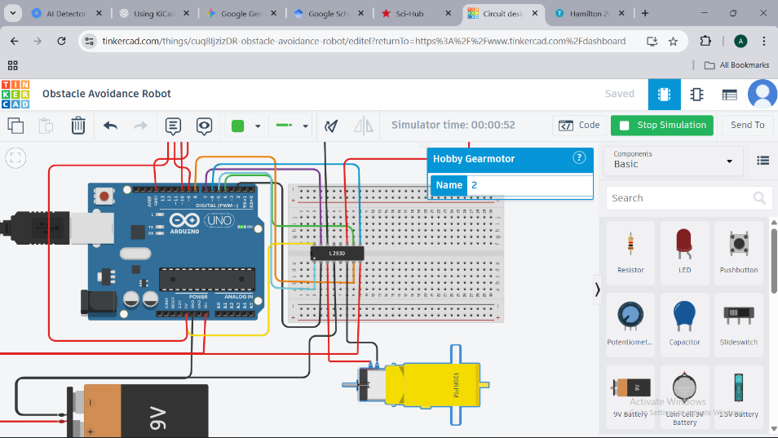
Figure 18: Screenshot of Simulation in Tinkercad

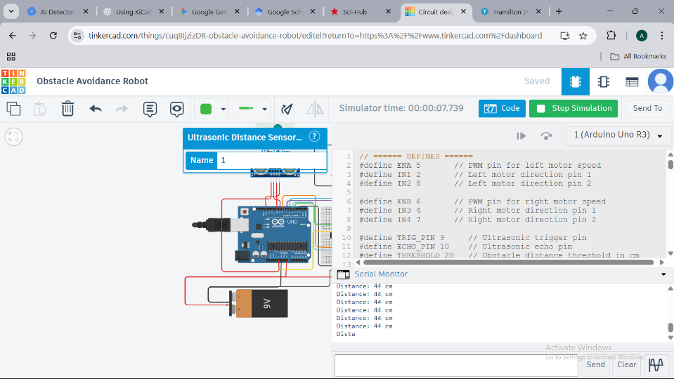
Figure 19: Serial Monitor results when the object was placed at a distance greater than the threshold
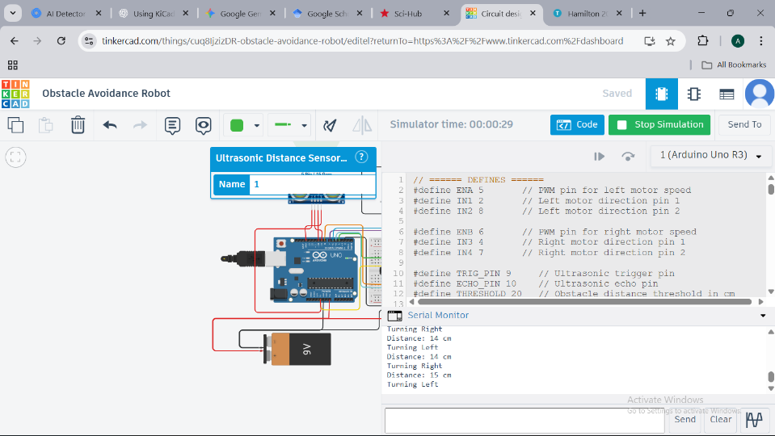
Figure 20: Serial Monitor result when object was placed at a distance less than the threshold

4.2 Hardware Results
A robot that can successfully detect and avoid obstacles was designed and constructed. After testing the physical prototype our Obstacle Avoiding Robot was able to perform the following functions
- Collision Avoidance: the robot had been able to detect obstacles in its path and successfully navigate around them to avoid collision.
- Smooth Navigation: the robot’s movement had been smooth and controlled as it changes directions to avoid obstacles.
- Adaptability: the robot had been able to adapt to changes in its environment.

4.3 PCB Performance Comparison
Compared to breadboard and wired connections, the PCB design provided improved electrical stability and consistent signal transmission. While breadboards are great for quick testing, they create flaky connections. By switching to a dedicated board, we eliminated those flaky connections entirely. This stability immediately translated into cleaner data from our sensors.
Beyond just physical toughness, the PCB allowed us to optimize the hidden side of the electronics:
- Rock-Solid Power: We were able to route power more effectively, ensuring the microcontroller and motors didn't lack voltage during high-demand moments.
- Quiet Signals: The organized layout acted as a shield against electromagnetic interference, keeping our signals crisp and reliable.
- Built to Last: Instead of a nest of wires that could snag or vibrate loose, we now have a compact, durable system that delivers the same performance every time you turn it on.
Breadboard vs PCB Performance Comparison Table
Feature | Breadboard | PCB
Feature | Breadboard Implementation | PCB Implementation
Signal Quality | High Noise / Interference | Low Noise / Shielded
Power Stability | Frequent Voltage Drops | Consistent Distribution
Durability | Fragile / Prone to Snagging | Robust / Impact Resistant
  Reliability
  Inconsistent during long operation
  Consistent and reliable

4.4 Discussion
The development of the obstacle-avoidance robot showed the advantages and disadvantages of the chosen hardware and design approach. The Arduino Uno acted as the brain of the operation, successfully receiving sensor data and motor commands. the motor driver provided the DC-motors with enough torque which allowed the robot to have smooth movements, while the PWM controlled motor speed for better turning effect while moving.
The sensor detected obstacles successfully within its range, but it was limited by some factors which were later mitigated. The addition of PCB to the system improved electrical stability, reliability, and reduced noise compared to a breadboard setup. Tinkercad and Proteus were perfect for testing our circuit logic, however it couldn’t replicate real world situation properly.
Overall, the project showed the principles of autonomous navigation and obstacle avoidance successfully. It provided valuable information about sensor integration, motor control, and PCB design, while also identifying challenges that must be addressed for real-world situations. The system’s design ensures that it can be upgraded with some features in the future.

4.5 Problems Encountered and Solution
During the creation and programming of an Obstacle Avoidance Robot, many issues were faced both on the creation of it physically and the programming of it.
- Sensor and Detection Limits: Standard Sensors have narrow view of detection, causing the robot to hit obstacles that are below the sensor or at their sides. The detection limitation of the sensor was reduced by carefully positioning the sensors and adjusting detection thresholds in the software. These adjustments helped improve overall system performance despite the sensors’ limitations.
- Insufficient Power Supply: The motors which were used draw significant current, which causes voltage drops that reset the microcontroller and leads to inaccurate sensor readings. The solution to this was we used a high discharge Lithium-ion with a stable 5V regulator
- Chassis Instability: Poor weight distribution and high center of gravity was causing the robot to tip over during sudden turns. Our solution to this was we kept heavy components like batteries as low as possible and used Pulse Width Modulation to smoothly ramp motor speeds up and down rather than starting at full power.
- Mechanical Issues: there was small delays in the motor response and uneven speeds. Several rounds of trial and error was executed to refine the code and get the movement feeling smooth.

CHAPTER FIVE

CONCLUSION AND RECOMMENDATION

5.1 Summary of Findings
The development of the Obstacle Avoidance Robot successfully integrated hardware and software to achieve self-steering robotic navigation. The primary findings from the testing phase include:
    - The ultrasonic sensors show high reliability in spotting solid objects.
    - The system enables easy mobile robot navigation.
    - Under continuous operation, the battery layout provides a norm runtime of about 2 hours, meeting the original project requirements.
    - While extremely effective in well-lit, flat indoor environments, showing a bit of degradation when encountering soft surfaces (which absorb ultrasonic waves) or steep inclines.

5.2 Conclusion
This project successfully accomplished its objective of designing and implementing a functional obstacle avoidance robot. By the use Arduino-based architecture and ultrasonic ranging, the robot can its way around complex environment without human intervention. The transition from miniatures (Proteus/Tinkercad) to a custom PCB seriously improved the robot’s systemic integrity and reduced signal noise. In conclusion, the project shows the low-priced ultrasonic sensors combined with efficient logic algorithms provide a robust foundation for self-steering mobile robotics.

5.3 Recommendations
- For Industry: Manufacturers should consider assimilating multi-modal sensing (combing Ultrasonic with LiDAR or infrared) to overcome the “blind spots” made by multiple material textures. Furthermore, applying modular PCB design would allow for easier maintenance and better industrial logistic robots.
- For Future Students: It is advisable to survey more advanced control algorithms, such as PID (proportional-integral-derivative) control, to accomplish smoother turning radii and more exact speed modulation.

5.4 Contribution to knowledge
This research contributes to the field of small-scale self-steering system by providing:
  - A documented comparison between breadboard prototype and custom PCB performance, highlighting the impact of trace impedance on sensor accuracy.
  - An optimized algorithm for real-time decision-making that minimizes “oscillatory behavior” (shaking) when the robot is trapped between two close obstacles.
  - An open-source framework (refer to GitHub link in Appendices) for low-cost educational robotics.

5.5 Limitations
Despite the successful addition, certain limitations were identified:
  - Material Sensitivity: The robot finds it hard to find sound-absorbent material like heavy foam or thick curtains.
  - Processing Powder: The current 8-bit microcontroller restricts the addition of complex machine learning or image processing tasks.
  - Static Logic: The robot runs on a fixed-threshold logic, meaning it cannot “learn” or adapt to new environment types dynamically.

5.6 Suggestion or Future Work
The development of this project can be improved by exploring the following areas:
- IoT Integration: A Wi-Fi or Bluetooth module can be added to our system which would allow monitoring of data obtained from the robot via a mobile application.
- Mapping Capabilities: Incorporating an IMU (Inertial Measurement Unit) and encoder to implement SLAM (Simultaneous Localization and Mapping) would enhance navigation accuracy and help improve motor speed and turning control.
- Machine Learning and AI: In the future machine learning algorithm could be applied to allow our robot to learn from its environment and improve its obstacle avoiding behavior over time.

REFERENCES
Arduino LLC. (n.d.). Arduino Uno technical documentation. https://www.arduino.cc
Arduino. (n.d.). Arduino Uno Rev3: Technical specifications and datasheet. Arduino. Retrieved from https://www.arduino.cc/en/Main/ArduinoBoardUno
Brooks, R. A. (1990). Elephants don't play chess. In Designing autonomous agents: Theory and practice from biology to engineering and back.
CajunBot Team, University of Louisiana at Lafayette. (2004). CajunBot autonomous vehicle for DARPA Grand Challenge. Wikipedia. https://en.wikipedia.org/wiki/CajunBot
Cytron Technologies. (n.d.). HC-SR04 ultrasonic sensor datasheet. Cytron Technologies. Retrieved from https://www.cytron.io/p-hc-sr04-ultrasonic-sensor
iRobot Corporation. (2002). Roomba: Autonomous robotic vacuum cleaner. https://www.irobot.com/about-irobot
Microchip Technology Inc. (n.d.). ATmega328P 8-bit AVR microcontroller datasheet. Microchip Technology Inc. Retrieved from https://ww1.microchip.com/downloads/en/DeviceDoc/ATmega328P-Data-Sheet-DS40002061A.pdf
Panasonic. (n.d.). AA NiMH rechargeable battery datasheet. https://www.panasonic.com
Pololu / Generic Manufacturer. (n.d.). DC geared motor technical specifications.
RAVON. (n.d.). RAVON. Agrosy Informatik. Retrieved June 18, 2021, from https://agrosy.informatik.uni-kl.de
Ridden, P. (2018, June 7). Parrot looks to the insect world for folding 4K camera drone. New Atlas. Retrieved November 3, 2025, from https://newatlas.com
Smith, J. (n.d.). Principles of autonomous navigation. Journal of Robotics, 12.
Texas Instruments. (n.d.). L293D quadruple half-H driver datasheet. Texas Instruments. Retrieved from https://www.ti.com/lit/ds/symlink/l293.pdf
Zhao, J., & F., J. (2021). Obstacle avoidance of multi-sensor intelligent robot based on road sign detection. MDPI. https://doi.org/10.3390/s21020456

APPENDICES

Appendix A: Full source Code
// ====== DEFINES ======
#define ENA 5 // PWM pin for left motor speed
#define IN1 2 // Left motor direction pin 1
#define IN2 8 // Left motor direction pin 2

#define ENB 6 // PWM pin for right motor speed
#define IN3 4 // Right motor direction pin 1
#define IN4 7 // Right motor direction pin 2

#define TRIG_PIN 9 // Ultrasonic trigger pin
#define ECHO_PIN 10 // Ultrasonic echo pin
#define THRESHOLD 20 // Obstacle distance threshold in cm

// ====== GLOBAL VARIABLES ======
bool turnSide = true; // true = turn right, false = turn left
long distance = 0;

// ====== SETUP ======
void setup() {
// Motor control pins as outputs
pinMode(ENA, OUTPUT);
pinMode(IN1, OUTPUT);
pinMode(IN2, OUTPUT);
pinMode(ENB, OUTPUT);
pinMode(IN3, OUTPUT);
pinMode(IN4, OUTPUT);

// Ultrasonic pins
pinMode(TRIG_PIN, OUTPUT);
pinMode(ECHO_PIN, INPUT);

Serial.begin(9600); // start serial communications at 9600 bps
}

// ====== MOTOR FUNCTIONS ======
void moveForward() {
digitalWrite(IN1, HIGH);
digitalWrite(IN2, LOW);
digitalWrite(IN3, HIGH);
digitalWrite(IN4, LOW);

analogWrite(ENA, 150);
analogWrite(ENB, 150);
}

void turnLeft() {
digitalWrite(IN1, LOW);
digitalWrite(IN2, HIGH);
digitalWrite(IN3, HIGH);
digitalWrite(IN4, LOW);

analogWrite(ENA, 150);
analogWrite(ENB, 150);
}

void turnRight() {
digitalWrite(IN1, HIGH);
digitalWrite(IN2, LOW);
digitalWrite(IN3, LOW);
digitalWrite(IN4, HIGH);

analogWrite(ENA, 150);
analogWrite(ENB, 150);
}

void stopRobot() {
digitalWrite(IN1, LOW);
digitalWrite(IN2, LOW);
digitalWrite(IN3, LOW);
digitalWrite(IN4, LOW);

analogWrite(ENA, 0);
analogWrite(ENB, 0);
}

// ====== ULTRASONIC FUNCTION ======
long readDistance() {
// Send trigger pulse
digitalWrite(TRIG_PIN, LOW);
delayMicroseconds(2);
digitalWrite(TRIG_PIN, HIGH);
delayMicroseconds(10);
digitalWrite(TRIG_PIN, LOW);

// Read echo pulse duration
long duration = pulseIn(ECHO_PIN, HIGH);

// Convert to distance in cm
long cm = duration * 0.034 / 2;
return cm;
}

// ====== LOOP ======
void loop() {
distance = readDistance();
Serial.print("Distance: ");
Serial.print(distance);
Serial.println(" cm");

if(distance < THRESHOLD) {
stopRobot(); // stop before turning

if(turnSide){
Serial.println("Turning Right");
turnRight();
} else {
Serial.println("Turning Left");
turnLeft();
}

delay(500); // Adjust turn duration
stopRobot();
delay(100); // Short pause

turnSide = !turnSide; // Flip direction for next obstacle
} else {
moveForward();
}
}

Appendix B: GitHub Repository
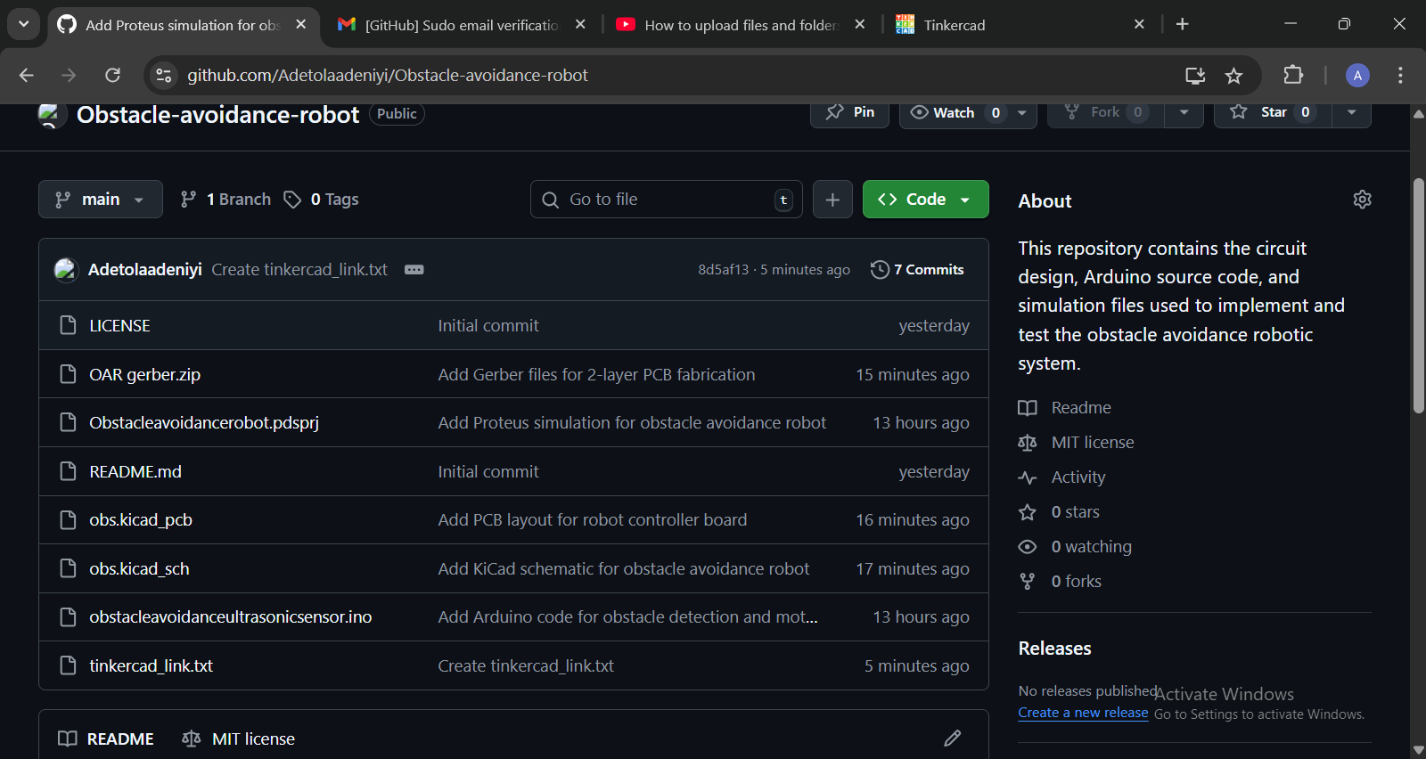
Figure 21: GitHub Repository Contributions via https://github.com/Adetolaadeniyi/Obstacle-avoidance-robot.git

Appendix C: Component Datasheets

Arduino Uno (ATmega328P)
Parameter | Datasheet Value
Operating Voltage | 5V
Input Voltage (recommended) | 7-12V
Clock Speed | 16MHz
Digital I/O Pins | 14
Analog Input Pins | 6
Max I/O Pin Current | 40mA

L293D Motor Driver
  Parameter
  Datasheet Value
Motor Supply Voltage (Vs) | 4.5–36 V
 | 5V
  Logic Supply Voltage (Vss)
Output Current
  600 mA per channel
Peak Output Current
  1.2 A
  Built-in Flyback Diodes
  Yes
Number of Channels
  2 H-bridges

DC Gear Motor
Parameter | Typical Value
Type | DC geared motor
Rated Voltage | 6–12 V
No-load Speed | ~200 RPM
Torque | Moderate
Parameter | Typical Value
Nominal Voltage | 1.5 V (Alk) / 1.2 V (NiMH)
Capacity | 1800–3000 mAh
Max Current | 500 mA – 1000 mA
Discharge | Gradual drop

NimH AA Battery
Parameter | Datasheet Value
Nominal Voltage | 1.2 V
Capacity | 1800–3000 mAh
Max Current | 500 mA – 1000 mA
Discharge | Gradual drop

HC-SR04 Ultrasonic Sensor
  Parameter
  Datasheet Value
  Operating Voltage
  5 V DC
  Operating Current
  ~15 mA
  Operating Frequency
  40 kHz
  Measuring Range
  2 cm – 400 cm
  Measuring Angle
  ~15°
  Distance Accuracy
  ±3 mm
  Trigger Input Signal
  10 µs TTL pulse
  Echo Output Signal
  TTL pulse width
  Response Time
  < 200 ms
  Interface Pins
  VCC, Trig, Echo, GND

